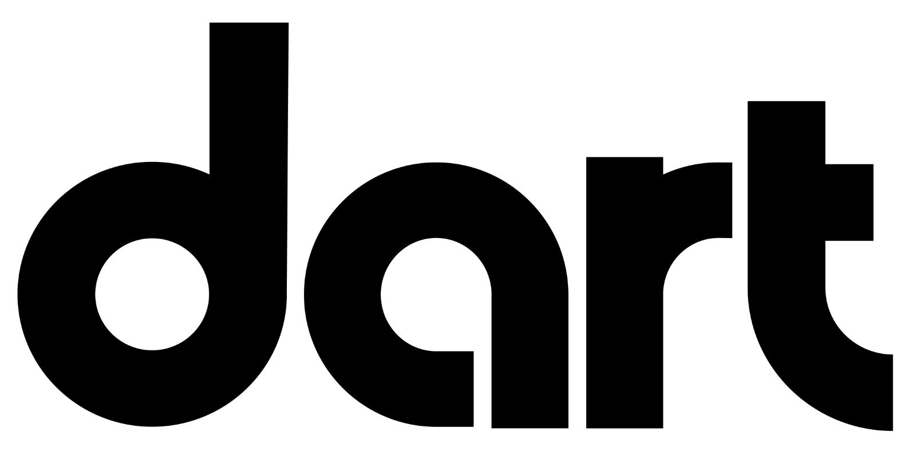

**Newsletter Article:** Rider Perspectives

**6 Reasons to Use Public Transportation**

DART provides 3.2 million rides in Greater Des Moines each year.  Curious why someone would ride DART? Let’s explore the top six reasons, according to a 2022 customer survey, and how a possible cut to bus services would impact people’s daily lives:

**#1: Work.** 57% of DART riders cited their job as a key reason they use public transit. Why? Because for thousands of central Iowans (including 61% of DART riders) there may not be a car in the garage and catching the bus makes earning a living possible.

**#2: Shopping.**15% ride the bus to make purchases, including groceries and necessary supplies.

**#3: Education.** 11% ride DART to school. Last year, DART provided approximately 525,000 rides to DMPS students. It also partners with four colleges and universities to provide free access to public transit.

**#4: Social & Recreation.** It’s true: 6% of DART riders use public transit for fun! Some ride to community events (like the Iowa State Fair or Downtown Farmers’ Market), while others ride DART to access public amenities like parks and libraries.

**#5: Health & Medical.** DART provides an avenue to use other essential services such as health and medical, as indicated by 3% of respondents. **Did you know:** DART’s variety of services help meet the needs of an aging population in central Iowa. Last fiscal year, DART provided more than 111,000 rides through paratransit, DART’s door-to-door service for those who need it.

**#6: Job-Seeking.** Finally, 2% ride DART when they need to find a job. With most central Iowa business leaders expressing concern they won’t be able to meet future workforce needs, public transit can help connect those seeking jobs to employment.*

Every day, DART helps thousands of central Iowans access services and opportunities that support a positive quality of life. And just like parks, libraries and emergency services, DART is an inclusive and equitable public service that is available to all of us.

***DART could face major service cuts without an increase in funding. Elected leaders need to hear your views on public transit.*** [***Learn more.***](https://ridedart.com/funding-our-future)

SOURCES:

* *DART and ETC Institute: Customer Survey 2022*
* *\*BPC and Bâton Global: Envision Iowa: Statewide Leaders Economic Outlook Survey Report 2022,* [*"87% of Iowa leaders express concern the state will not be able to meet workforce needs"*](https://businessrecord.ac-page.com/envision-iowa)