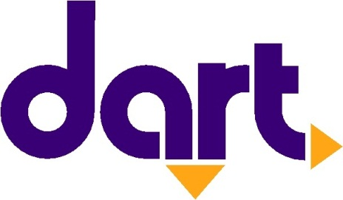

Contact
Erin Hockman
Des Moines Area Regional Transit Authority
ehockman@ridedart.com
515-499-3069

FOR IMMEDIATE RELEASE:

Wednesday, Feb. 15, 2023

Beginning Sunday, DART will add three more trips to Route 15
Schedule adjustments to DART’s 6th Avenue route will create additional opportunities for evening travel towards Downtown Des Moines

GREATER DES MOINES, IA – Des Moines Area Regional Transit Authority (DART) will add trips for riders utilizing Route 15 – 6th Avenue in Des Moines, resulting in additional opportunities to travel towards Downtown in the evenings. This schedule improvement is part of DART’s regularly planned service change beginning Sunday, February 19.

Route 15 operates between DART Central Station (620 Cherry Street) and Park Fair Mall, servicing MercyOne Des Moines Medical Center, Harding Middle School, North High School and Iowa Events Center. Three additional inbound trips ending at DART Central Station will be added including one new weekday trip and two new Saturday trips — each taking place in the evening.

“We are fine-tuning the schedule for Route 15 based on feedback from our customers,” said DART’s Chief Planning Officer, Luis Montoya. “We figured out a way to provide a bit more service in a cost-neutral manner, which we hope will provide more value to the communities we serve. It’s truly a win-win.”

The additional trips along Route 15 will include:
- On weekdays, a new trip will leave Park Fair Mall at 6:37 p.m. and will arrive at DART Central Station at 6:49 p.m.
- On Saturdays, a new trip will leave Park Fair Mall at 9:37 p.m., arriving at DART Central Station at 9:50 p.m.
- Additionally on Saturdays, another trip will leave Park Fair Mall at 10:07 p.m. and will arrive at DART Central Station at 10:20 p.m.

The new schedules for Route 15 are available on DART’s website and paper schedules are accessible for riders on buses and at DART Central Station.

Learn more at ridedart.com/February.

ABOUT DART
The Des Moines Area Regional Transit Authority (DART) is Iowa’s largest, and only, regional transit agency, providing service in and around Polk County. DART operates a family of transportation services, providing nearly 3 million annual rides that connect thousands of people every day to jobs, school, healthcare and other essential destinations. Twelve member governments make up DART's service area, where the agency carries out its mission to enrich lives, connect communities and expand opportunities for central Iowans. For more information about DART services, schedules, route changes, or directions to the nearest DART stop, visit the website at ridedart.com, download the free MyDART app or call 515-283-8100.

# # #

