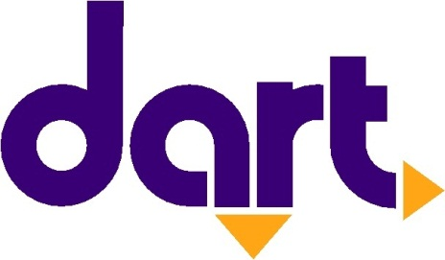

Contact
Erin Hockman
Des Moines Area Regional Transit Authority
ehockman@ridedart.com
515-499-3069
FOR IMMEDIATE RELEASE:

February 3, 2023

DART honors civil rights activist Rosa Parks
A seat on each bus will be reserved on February 4 for Rosa Parks Day

This Saturday, February 4, is civil rights activist Rosa Parks’ birthday. To honor her legacy DART will “reserve” the first seat on every bus for Mrs. Parks.

Rosa Parks, born in 1913 in Tuskegee, Alabama, was an active member of the Montgomery chapter of the National Association for the Advancement of Colored People (NAACP) and advocated for racial justice. On December 1, 1955, she refused to give up her seat on a Montgomery public bus for a white man, in defiance of “Jim Crow” segregation laws. This brave action sparked the Montgomery Bus Boycott, a critical part of the Civil Rights Movement.

“Rosa Parks did something revolutionary for her time–she stood up for herself as a black woman during Jim Crow in the South,” said DART’s Diversity, Equity and Inclusion Committee co-chairs, Georisha McGregor and Catlin Curry. “Her single action is a reminder to us all that in order to move towards a more equitable future that we have to take action ourselves. As a public transportation provider, we have the opportunity each and every day to work alongside our communities and riders to create a more equitable transportation system. As co-chairs for DART’s Diversity, Equity and Inclusion efforts, we are proud to be part of that work.”

February 4th is now known as Rosa Parks Day, and DART has chosen to commemorate the occasion by dedicating a seat on every bus in honor of Mrs. Parks. DART proudly salutes Mrs. Parks and reaffirms its commitment to providing equitable public transportation in Greater Des Moines.

More information on DART’s acknowledgement of Rosa Parks is available at ridedart.com/rosaparks.

# # #

ABOUT DART
The Des Moines Area Regional Transit Authority (DART) is Iowa’s largest, and only, regional transit agency, providing service in and around Polk County. DART operates a family of transportation services, providing nearly 4.5 million annual rides that connect thousands of people every day to jobs, school, healthcare and other essential destinations. Twelve member governments make up DART's service area, where the agency carries out its mission to enrich lives, connect communities and expand opportunities for central Iowans. For more information about DART services, schedules, route changes, or directions to the nearest DART stop, visit the website at ridedart.com, download the free MyDART app or call 515-283-8100.

