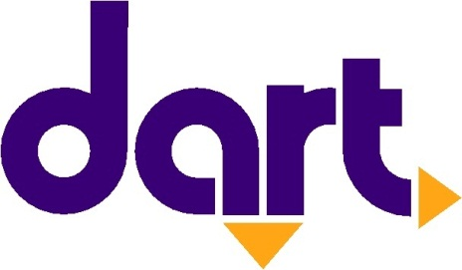

Contact
AMANDA WANKE
Des Moines Area Regional Transit Authority
awanke@ridedart.com
515-360-2125

FOR IMMEDIATE RELEASE:

Monday, November 21, 2016

No DART Service on Thanksgiving Day

The Des Moines Area Regional Transit Authority (DART) will not operate bus service on Thursday Nov. 24, 2016, for the Thanksgiving Holiday. Regular service will resume on Friday, Nov. 25, 2016.

Thursday, Nov. 24 – No DART service in observation of the Thanksgiving Day holiday. DART Central Station and the administrative offices are closed.

Friday, Nov. 25 – DART services will operate on its regular Friday schedule. Hours for the customer service window and schedule information phones are 6:30 a.m. to 7 p.m. Administrative offices are closed.

For more information, please visit ridedart.com or call DART Customer Service at 515-283-8100.

The Des Moines Area Regional Transit Authority is the public transportation provider that serves Polk County. DART operates a family of transportation services that makes getting around the Greater Des Moines area easier and more convenient. For more information about DART services, schedules, route changes, or directions to the nearest DART stop, visit the website at www.ridedart.com or call 515-283-8100. The MyDART Tools, Trip Planner and RideTime Transit app are now available at www.ridedart.com.

# # #

